Project Design Phase-II

Data Flow Diagram & User Stories
Date: 28 February 2026
Team ID: LTVIP2026TMIDS60852
Project Name: Dream Nest – House Rent, Vacation & Villa Booking Platform
Maximum Marks: 4 Marks

Data Flow Diagrams
The Data Flow Diagram (DFD) represents how data flows within the Dream Nest system. It shows how users interact with the system, how authentication and booking are handled, and how data is stored in MongoDB.

DFD Level 0 (Context Diagram)
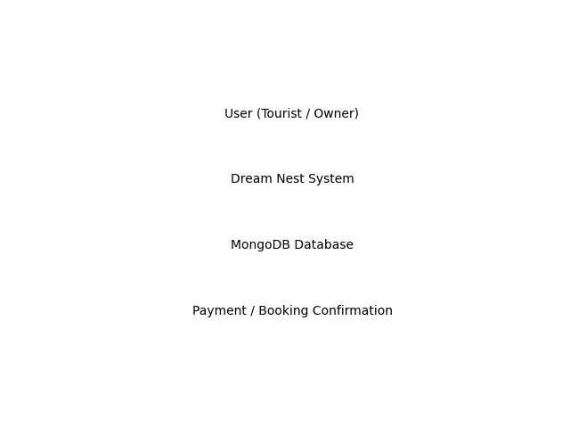

DFD Level 1 (Detailed Diagram)
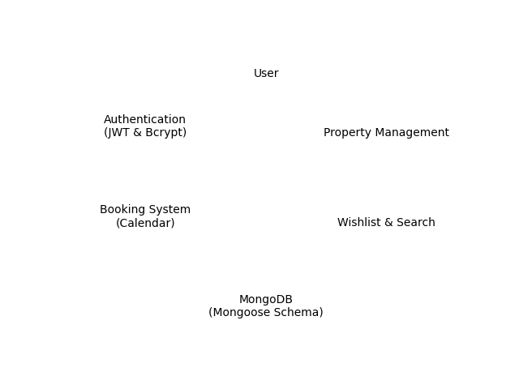

User Stories
User Type | Functional Requirement (Epic) | User Story No | User Story | Acceptance Criteria | Priority | Release
Tourist / User | Authentication | USN-1 | As a user, I want to register and login securely so that my data is protected. | User can sign up/login using JWT authentication and password encryption. | High | Sprint-1
Property Owner | Listing Management | USN-2 | As an owner, I want to create property listings with images and details. | Listing is stored in MongoDB and visible in property feed. | High | Sprint-1
User | Booking System | USN-3 | As a user, I want to book properties using a calendar system. | Booking dates are stored and reservation confirmation is generated. | High | Sprint-1
User | Search & Filter | USN-4 | As a user, I want to search properties by keyword and category. | Filtered results are displayed correctly based on search input. | High | Sprint-1
User | Wishlist | USN-5 | As a user, I want to add or remove properties from wishlist. | Wishlist updates in real-time using Redux state management. | Medium | Sprint-2
Admin/System | Security & Data Management | USN-6 | As a system, I want secure database storage using Mongoose schema. | Data is validated and securely stored in MongoDB. | High | Sprint-1

